**Tech Saksham**

**Case Study Reporthttps://github.com/9360892173vishnu/Real-time-analysis-of-bank-customers.git**

**Data Analytics With Power BI**

**‘’Real Time Analysis Of Bank Customers’’**

|  |  |
| --- | --- |
| **NM ID** | **NAME** |
| **B49520BA62FE227829C41E9F5931656A** | **S.divyadharshini** |

**‘’NMS SERMATHAI VASAN COLLEGE FOR WOMEN’’**

**Trainer Name ; R.Umamaheshwari**

**Master Name;R.Umamaheswari**

**ABSTRACT**

In the digital age, data has become an invaluable asset for businesses, particularly in the banking sector. The proposed project, “Real-Time Analysis of Bank Customers,” aims to leverage PowerBI, a leading business intelligence tool, to analyze and visualize real-time customer data. This project will enable banks to gain deep insights into customer behavior, preferences, and trends, thereby facilitating data-driven decision-making and enhancing customer satisfaction. The real-time analysis will allow banks to respond promptly to changes in customer behavior or preferences, identify opportunities for cross-selling and up-selling, and tailor their products and services to meet customer needs. The project will also contribute to the broader goal of digital transformation in the banking sector, promoting efficiency, innovation, and customer-centricity.

|  |  |  |
| --- | --- | --- |
| 1. | Chapter1:introduction |  |
| 2. | Chapter 2: Services and Tools Required |  |
| 3. | Chapter 3: Project Architecture |  |
| 4. | Chapter 4: Modeling and Result |  |
| **5.** | Conclusion |  |
| **6.** | Future Scope |  |
| **7.** | References |  |

**Chapter-1**

**Introduction:**

**Real-time banking analytics:**

The digital banking transformation has been made

possible thanks to the technological advances in recent years and the

ability to manage and analyse large volumes of data more efficiently and

quickly.

This digital evolution has been based on the

development of Big Data, Artificial Intelligence and large-scale analytics

, such as, for example, **real-time data analysis, which is a large part of**

**Latinia’s value proposition**, and key to boosting the personalisation of

financial services and improving the banking customer experience.

## ****WHY SHOULD BANKS CHOOSE REAL-TIME ANALYTICS?****

All industries currently recognise the value and

power of data as a source of knowledge about the customer; this is

especially true for the financial industry.

Data analytics, whether they are descriptive,

predictive or prescriptive, can **detect patterns and customer**

**behaviour in order to predict situations;** in this way, companies

can make quicker decisions, recommend personalised products and

services and, in short, improve the relationship between banks and

their customers through convenience and proactivity.

According to David Andrzejek, head of financial

services at DataStax for [Global Finance & Banking Review](https://www.globalbankingandfinance.com/banks-and-real-time-data-are-they-running-out-of-time/), “modern

banking services rely on data being used in context and in real time.

Consumers today expect their bank to help them

manage their money more efficiently and in their best interests.”

**Real-time analytics offer the opportunity for**

**banks to consistently tap into customers’ daily lives**, identifying

the right time to provide the information the customer needs and even

getting ahead of problems that may arise regarding their finances.

For example, alerting consumers before they

make a purchase if it exceeds their available balance, supporting

immediate credit decisions or allowing the customer to use a buy

now, pay later service.

“The possibilities opened up by filtering and

analysing transactional events and customer intelligence data in real

time are extraordinary.

**At Latinia we are experts in the development**

**of this type of products and our solutions aim to enable banks to**

**consistently connect with their customers in a personalised**

**way,** both inside and outside the bank’s digital channels, anticipating

potential problems that may arise and providing solutions in real

time”, Francesc Pérez, the Chief Revenue Officer at Latinia, states.

## ****THE ADVANTAGES OF REAL-TIME ANALYTICS****

For John Mitchell, CEO and Co-Founder of

Episode Six, “by leveraging real-time analytics, banks are better

equipped to create an enhanced customer experience, overcome

constraints of legacy technology, drive greater value from customers

and combat fraud”, as he explains in this article published

in [International Finance](https://internationalfinance.com/real-time-analytics-a-tipping-point/).

Let’s take a closer look at each of these advantages

**Maximum experience customisation.**

Traditional banks must now assert their

leadership position in the financial market against new competitors;

real-time analytics provide accurate of-the-moment insight into

customer behaviours, preferences and financial history. Technology

and data provide valuable knowledge about customers and help build

stronger, longer lasting and, above all, more bespoke relationships.

**The fight against cyber fraud**

 Real-time data analytics help to detect and

monitorfraudulent transactions, thus mitigating the impact of cyber

crimes on the financial sector.

Banking needs to move towards the widespread

application of this type of analytics to meet today’s challenges

and, at the same time, learn to prevent new fraud techniques.

**Opportunity for growth.**

The impact of real-time analytics on the business

model of financial institutions is significant and will be

amplified by the increasing deployment of artificial

intelligence, which will enable a more intuitive and advanced

analysis of knowledge about the customer.

Scope:

The scope of this project extends to all banking institutions that aim

to leverage data for decision-making and customer engagement. The

project can be further extended to incorporate *more* data sources and

advanced analytics techniques, such as machine learning and artificial

intelligence, to provide more sophisticated insights into customer

behavior. The project also has the potential to be adapted for other

sectors, such as retail, healthcare, and telecommunications, where

understanding customer behavior is crucial. Furthermore, the project

contributes to the broader goal of digital transformation in the

banking sector, promoting efficiency, innovation, and

customercentricity.

**Chapter-2**

**SERVICES AND TOOLS REQUIRED :**

Services Used

• Data Collection and Storage Services: Banks need to collect and store customer data in real-time. This could be achieved through services like Azure Data Factory, Azure Event Hubs, or AWS Kinesis for real-time data collection, and Azure SQL Database or AWS RDS for data storage

. • Data Processing Services: Services like Azure Stream Analytics or AWS Kinesis Data Analytics can be used to process the real-time data

. • Machine Learning Services: Azure Machine Learning or AWS SageMaker can be used to build predictive models based on historical data.

**Tools and Software used Tools:**

• PowerBI: The main tool for this project is PowerBI, which will be used to create interactive dashboards for real-time data visualization.

• Power Query: This is a data connection technology that enables you to discover, connect, combine, and refine data across a wide variety of sources.

**Software Requirements:**

• PowerBI Desktop: This is a Windows application that you can use to create reports and publish them to PowerBI.

• PowerBI Service: This is an online SaaS (Software as a Service) service that you use to publish reports, create new dashboards, and share insights

• PowerBI Mobile: This is a mobile application that you can use to access your reports and dashboards on the go.

Chapter-3

**PROJECT ARCHITECTURE**

Here’s a high-level architecture for the project:

1. Data Collection: Real-time customer data is collected from various sources like bank transactions, customer interactions, etc. This could be achieved using services like Azure Event Hubs or AWS Kinesis.

2. Data Storage: The collected data is stored in a database for processing. Azure SQL Database or AWS RDS can be used for this purpose.

3. Data Processing: The stored data is processed in real-time using services like Azure Stream Analytics or AWS Kinesis Data Analytics

. 4. Machine Learning: Predictive models are built based on processed data using Azure Machine Learning or AWS SageMaker. These models can help in predicting customer behavior, detecting fraud, etc.

5. Data Visualization: The processed data and the results from the predictive models are visualized in real-time using PowerBI. PowerBI allows you to create interactive dashboards that can provide valuable insights into the data

6. Data Access: The dashboards created in PowerBI can be accessed through PowerBI Desktop, PowerBI Service (online), and PowerBI Mobile.

Chapter-4

**MODELING AND RESULT**

Manage relationship

The “disp” file will be used as the main connector as it contains most key identifier (account id, client id and disp id) which can be use to relates the 8 data files together. The “district” file is use to link the client profile geographically with “district id’’

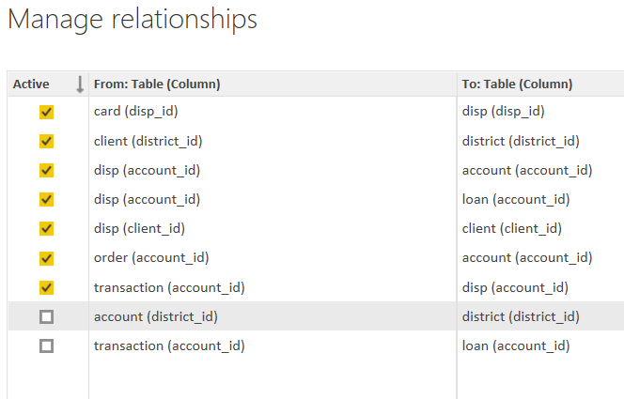

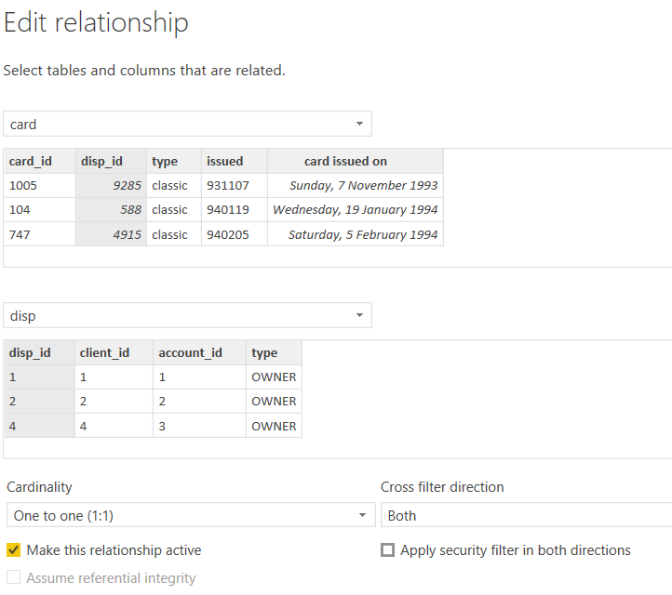

**Modelling for Gender and Age data**

Notice that the Gender and age of the client are missing from the data. These can be formulated from the birth number YYMMDD where at months (the 3rd and 4th digits) greater than 50 means that client is a Female. We can create a column for Gender.

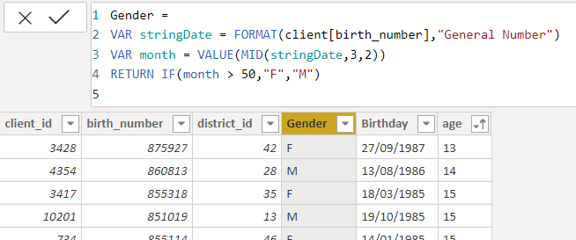

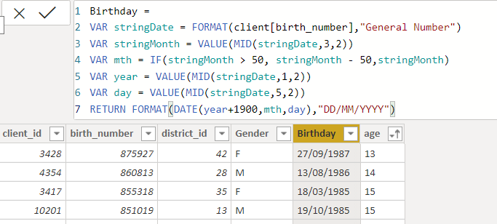

For Age, we shall assume it is year 1999 as explain previously and use it to minus from the birth year.

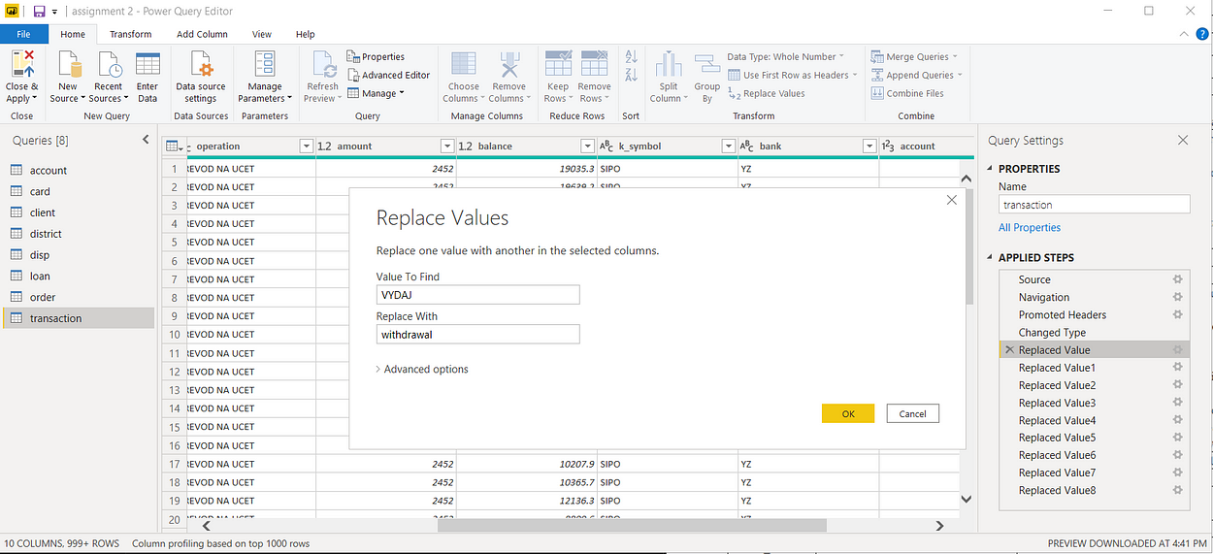

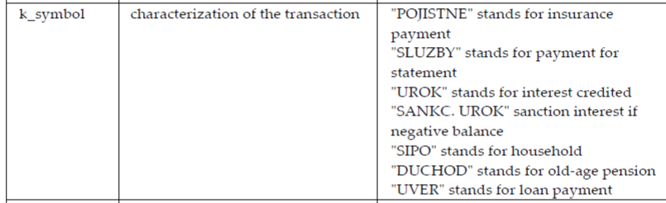

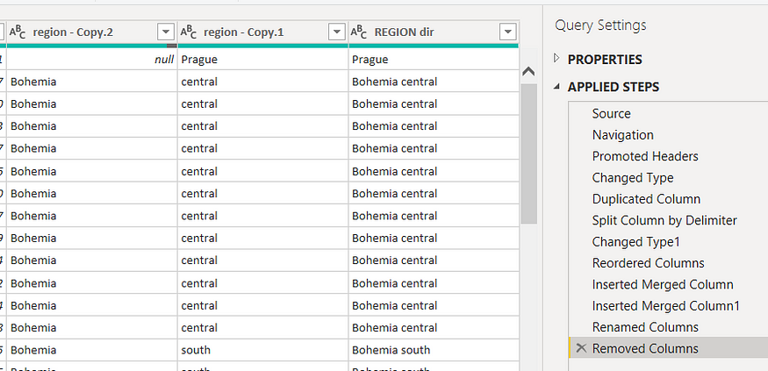REAL TIME ANALYSIS

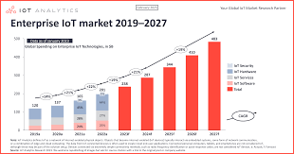

**CONCLUSION**

The project “Real-Time Analysis of Bank Customers” using PowerBI has successfully demonstrated the potential of data analytics in the banking sector. The real-time analysis of customer data has provided valuable insights into customer behavior, preferences, and trends, thereby facilitating informed decision-making. The interactive dashboards and reports have offered a comprehensive view of customer data, enabling the identification of patterns and correlations. This has not only improved the efficiency of data analysis but also enhanced the bank’s ability to provide personalized services to its customers. The project has also highlighted the importance of data visualization in making complex data more understandable and accessible. The use of PowerBI has made it possible to present data in a visually appealing and easy-to-understand format, thereby aiding in better decision-making.

**FUTURE SCOPE**

The future scope of this project is vast. With the advent of advanced analytics and machine learning, PowerBI can be leveraged to predict future trends based on historical data. Integrating these predictive analytics into the project could enable the bank to anticipate customer needs and proactively offer solutions. Furthermore, PowerBI’s capability to integrate with various data sources opens up the possibility of incorporating more diverse datasets for a more holistic view of customers. As data privacy and security become increasingly important, future iterations of this project should focus on implementing robust data governance strategies. This would ensure the secure handling of sensitive customer data while complying with data protection regulations. Additionally, the project could explore the integration of real-time data streams to provide even more timely and interact with their customers, leading to improved customer satisfaction and loyalty.

LINK: